SWE440 Individual Project 5

Zach Sharpe

Colorado Technical University

Table of Contents

Project Outline Overview 4

Agile Pros: 4

Agile Cons: 5

Tasks, Milestones, and Timeline 5

Risk Assessment 6

Human Resource Plan 8

Introduction 8

Example Human Resource Breakdown 8

Work Breakdown Structure 10

Summary 10

Work Breakdown Structure Layout 10

Project Budgeting and Estimation 11

PERT Estimation 11

An overall PERT estimation would see estimations for the duration of the entire project: 11

Budget Estimation 11

Analogous Estimation 11

Delphi Estimation 12

Metric Consideration During Estimation & Planning Period 13

FinTech Tool and Chart Breakdown 14

References 15

# Project Outline Overview

Financial company, FinTech, and its stakeholders have agreed upon a project outline, based on Agile methodology and Scrum principles. This outline details initial planning stages including requirements gathering, outlining, resource assignment, and prioritization. Initial development plan is subject to change as we plan to remain as flexible as possible.

We chose Agile methodology for several reasons with it’s provided flexibility being the key point. While leaning on Ambysoft’s detail of Agile application development, specifically with robust initiation phases, we came across a guiding principle, “Solution development is complicated. … If you adopt a development process that doesn't actually address the full development cycle then you've adopted little more than consultant ware in the end. My experience is that you need to go beyond the construction life … to the full SDLC.” 2. Below are the standout points we found when weighing development models:

## Agile Pros:

* A single project manager will be at the helm for creative decisions during development. This will help narrow decision-making and segment responsibility.
* Agile's flexibility lends itself to the stakeholders' needs for a tight knit, quickly changing business space.
* Scrum encourages open communication and rewards it with efficient development and individually rewarding work.
* The development of FinTech will need to be very iterative as this is the first financial software created by the team. Iterations of development can allow for mistakes and fine-tune improvement if necessary.
* To support iteration, two week term sprints will be the iterative timeframes our development team works within

## Agile Cons:

- Financial software handles the most sensitive of customer data, which puts the controller and handler at greater risk.

- Banking software is among the most targeted type of application in cyber-attacks.

- Without proper requirements and planning, scope creep can occur from the due diligence required in this type of development.

## Tasks, Milestones, and Timeline

Lastly, a schedule has been created with an agile framework for FinTech’s initial development of its foundational products: Financial and management accounting, financial supply chain management, and treasury applications.

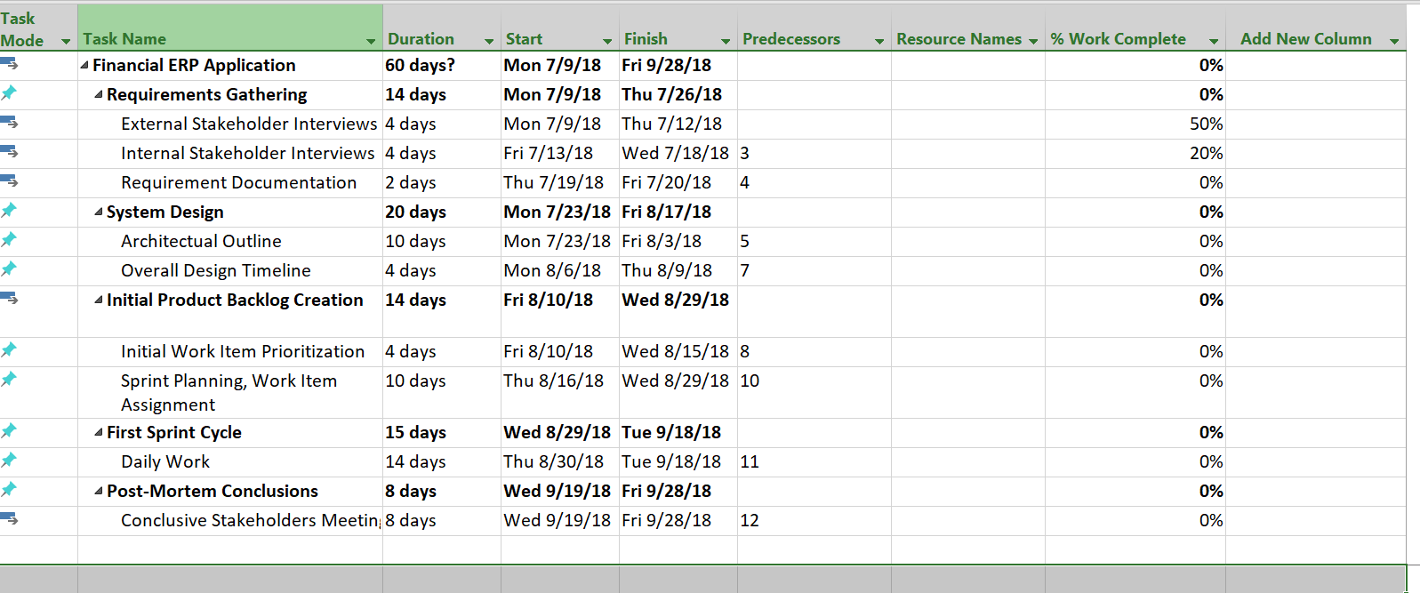

# Risk Assessment

A general overview of risk consideration is broken down in help by Project-Management.com’s principles around risk assessment and the provided template:

|  |  |  |
| --- | --- | --- |
| **Risk Breakdown Structure FinTech** | | |
| **External** |  |  |
|  | Environment |  |
|  |  | Natural Environment |
|  |  | Site and facilities |
|  |  | Local services |
|  |  | Political environment |
|  |  | Legal environment |
|  |  | Cultural environment |
|  | Market |  |
|  |  | Labor conditions |
|  |  | Financial conditions |
|  |  | Competition |
|  |  | Demand |
| **Project-related (internal)** | |  |
|  | Organization and Management | |
|  |  | Financial constraints |
|  |  | Organization stability |
|  |  | Organization experience |
|  |  | Organization culture |
|  |  | Organization location |
|  |  | Management experience |
|  | Customer |  |
|  |  | Requirement definition |
|  |  | Requirement uncertainty |
|  |  | Requirement complexity |
|  |  | Relationship with the customer |
|  | Technology |  |
|  |  | Technology availability |
|  |  | Technology maturity |
|  |  | Technology limits |
|  | Personnel/Material resources |  |
|  |  | Personnel skill set |
|  |  | Personnel experience |
|  |  | Resource availability |
|  |  | Quality of material resources |

In addition to the awareness items listed in the above structure, FinTech will consider priority for each risk item. This will be done prior to development in order to be best prepared during the initial sprint cycle.

In the case that risks need to be evaluated and listed during production, priority will be assigned these risks as well and considered for future sprint cycles.

# Human Resource Plan

## Introduction

Our human resource plans will layout the proper roles and responsibilities for all members of the development team during the development of FinTech. Furthermore, each role will be listed with their responsibility and competencies relevant to this job. The human resource plan will be updated throughout development as new members join and leave the team.

## Example Human Resource Breakdown

Utilizing principles detailed in ProjectManagementDocs.com 4 a visual of how this is laid out can be found here:

Engineering Lead (2 Positions) : Responsible for managing the direct development team and communication of needs between PM and team. Heavily involved in decision-making, risk assessment, and sprint planning. Must be consulted for ALL changes. Must also be consulted for all hiring for the direct management team. Little to no involvement with hiring on non-relevant teams.

“Project Manager (PM), (1 position): responsible for the overall success of the Software Upgrade Project. The PM must authorize and approve all project expenditures. The PM is also responsible for approving that work activities meet established acceptability criteria and fall within acceptable variances. The PM will be responsible for reporting project status in accordance with the communications management plan. The PM will evaluate the performance of all project team members and communicate their performance to functional managers. The PM is also responsible for acquiring human resources for the project through coordination with functional managers. The PM must possess the following skills: leadership/management, budgeting, scheduling, and effective communication.” 4

# Work Breakdown Structure

## Summary

FinTech’s work breakdown structure will detail different milestones and area of work. This will include crucial details at a glance and a high level overview on how work on FinTech will progress over time. The WBS will be established completely before development begins. A major aspect of a WBS is to help track budget during development. Utilizing WorkBreakdownSTructure.com’s guiding principles, the following summary is stated, “A project budget can be allocated to the top levels of the work breakdown structure, and department budgets can be quickly calculated based on the each project's work breakdown structure. By allocating time and cost estimates to specific sections of the work breakdown structure, a project schedule and budget can be quickly developed. As the project executes, specific sections of the work breakdown structure can be tracked to identify project cost performance and identify issues and problem areas in the project organization.” 5

## Work Breakdown Structure Layout

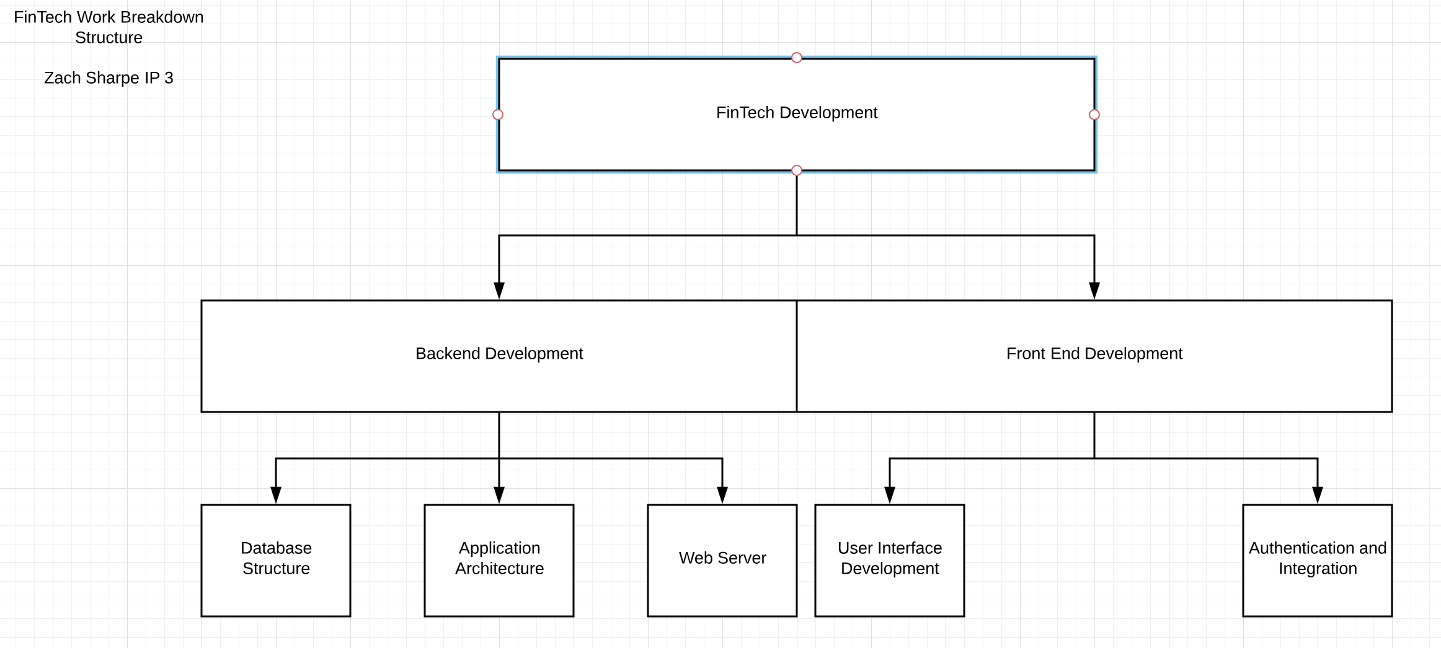

# Project Budgeting and Estimation

## PERT Estimation

A PERT estimation will help the project even out expectation in terms of work effort. PERT will be used to calculate estimated time to complete for several tasks utilizing the following principles 6:

**Most optimistic**: This involves work effort in which few variables affect the task. Rule of thumb: If the same task were to be performed 50 times, you would come to this estimate only once.

**Most likely:**This involves work effort in which a normal amount of variables affect the task. Rule of thumb: If the same task were to be performed many times under the same circumstances, this is general amount of time it would take.

**Most pessimistic:**This involves work effort in which a large number of variables affect the task. Rule of thumb: If the same task were to be performed 50 times, you would exceed this estimate one time.

## An overall PERT estimation would see estimations for the duration of the entire project:

Optimistic Estimation for completion of FinTech: 45 Days

Likely Estimation for completion of FinTech: 60 Days

Pessimistic Estimation for completion of FinTech: 90 Days

Estimation = (45+240+90) / 6

Our ultimate estimation for completion comes out to be 62.5 Days.

## Budget Estimation

### Analogous Estimation

Analogous estimating allows us to utilize past projects to inform the budgeting of our current plan. While based in data, analogous estimation can be inaccurate when compared to in depth estimation techniques. Project management site 4PM sets forth some guidelines on analogous estimating 7:

1. You identify previously completed projects with archived data on work and cost by task and major deliverable. In organizations with mature project management processes, like established consulting or engineering firms, there may be a number of similar projects.
2. On projects larger than the very smallest, you should include team members, stakeholders and the sponsor in examining the previous projects. They will help develop factors for adjusting the work and cost data.
3. You should guide the group to consensus on the adjustment factor. Then use this as the basis for the business case and the work and cost estimates.

Utilizing these principles we will conduct brief interviews with past product managers and engineering managers. Additionally we will expend three days for past data auditing helping us inform our budget for the currently cycle.

### Delphi Estimation

Delphi, or Wideband Delphi in this case is a type of estimation that will allow the project team to estimate cost and duration based on panel interviews. FinTech will conduct these along with a third part for proctoring. Wideband Delphi examination will take place in conjunction with the interviewing portions of Analogous Estimating. The result will be a three round panel interview asking the following questions, representing each phase of surveying:

* For (each task in project) what do you estimate in terms of time spent?
* (The following day) review your total estimation across all tasks and rewrite.
* Based on previous, identical, projects, place a cost estimate for the entire project broken down by task.

## Metric Consideration During Estimation & Planning Period

Many metrics will be used to keep both the engineering managers and project managers informed. The metrics utilized during FinTech’s product development are:

* At the end of each major task, what is our actual time spent versus the results of Delphi Estimation and PERT result of 62 days (divided evenly)?
* Four times per sprint cycle, evaluate budget progress and compare actual versus Analogous Estimation and normal project planning budget estimations. Make necessary adjustments.
* At the half way mark perform all estimation techniques (Wideband Delphi, Analogous, and PERT) again to compare changes and adjustments that had been performed up to that point.

## 

# FinTech Tool and Chart Breakdown

Scheduling & Tracking Progress (Work Breakdown Structure)

Dependencies between tasks

Program Evaluation Review Technique (PERT)

Risk management

# References

1 Agile Methodology: The Complete Guide to Understanding Agile Testing - QASymphony. (2017, August 15). Retrieved from <https://www.qasymphony.com/blog/agile-methodology-guide-agile-testing/>

2 The Agile System Development Life Cycle (SDLC). (n.d.). Retrieved from <http://www.ambysoft.com/essays/agileLifecycle.html>

3 Understanding the Risk Breakdown Structure (RBS). (2015, August 12). Retrieved from <https://project-management.com/understanding-the-risk-breakdown-structure-rbs/>

4 Administrator. (n.d.). Human Resource Plan Template. Retrieved from <http://www.projectmanagementdocs.com/project-planning-templates/human-resource-plan.html#axzz5MHVApjQF>

5 What is a Work Breakdown Structure - Workbreakdownstructure.com. (n.d.). Retrieved from http://www.workbreakdownstructure.com/

6 Asset Page. (n.d.). Retrieved from <https://class.ctuonline.edu/_layouts/MUSEViewer/Asset.aspx?MID=11911910&aid=11911948>

7 Analogous Estimating. (2017, May 25). Retrieved from https://4pm.com/2017/05/25/analogous-estimating/